AD3251 - Data Structures Design Subject Performance

## Performance Chart:

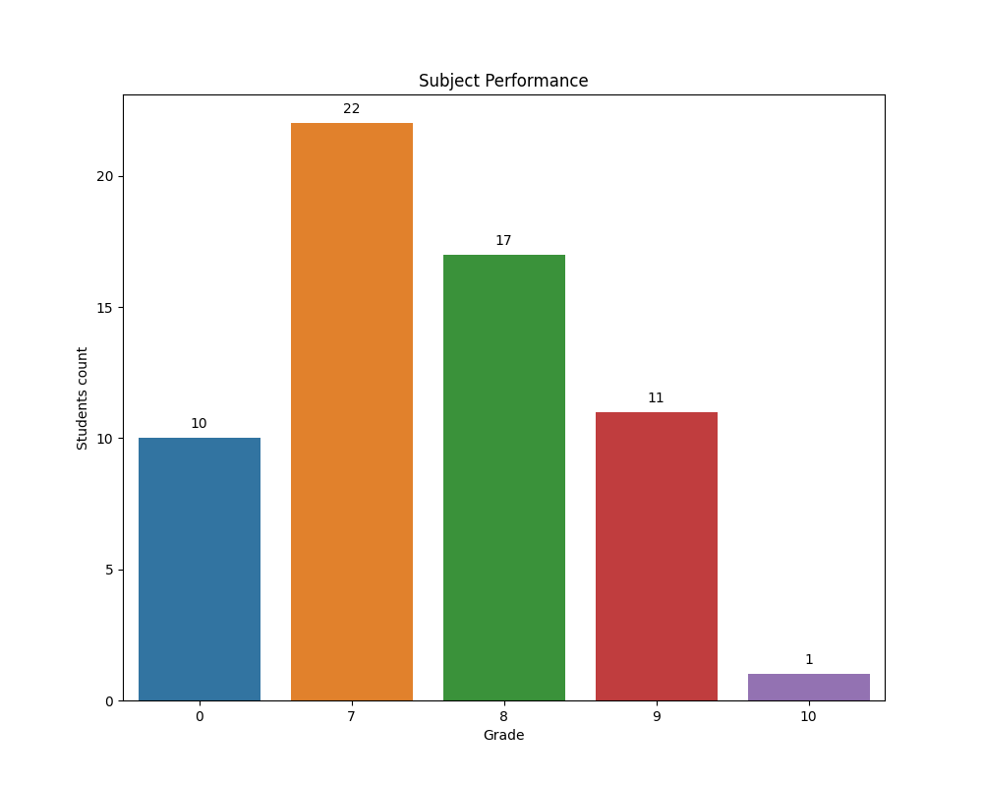

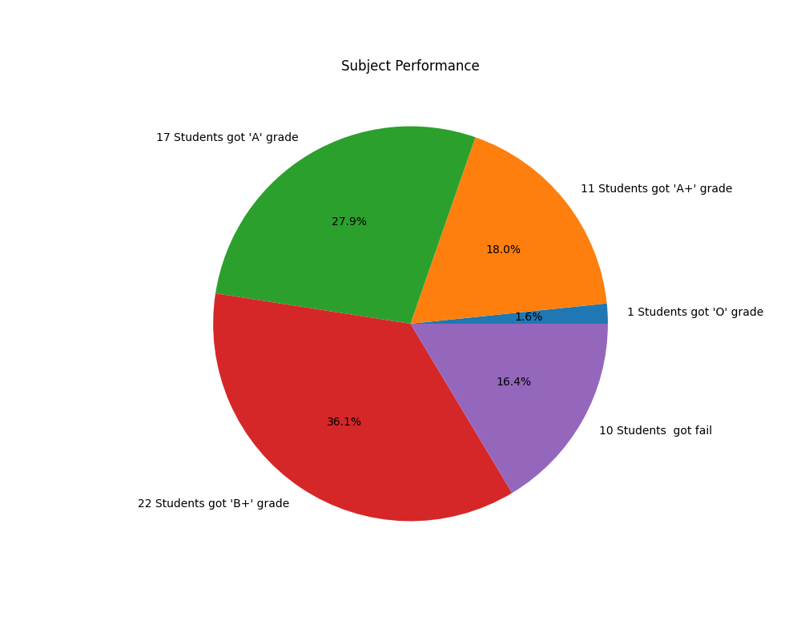

## Performance Summary:

The 1 Students got 'O' grade in the AD3251 Subject.  
 The 11 Students got 'A+' grade in the AD3251 Subject.  
 The 17 Students got 'A' grade in the AD3251 Subject.  
 The 22 Students got 'B+' grade in the AD3251 Subject.  
 The 10 Students got fail in the AD3251 Subject.

### Student Have O Grade:

GOPIKA R

### Student Have A+ Grade:

AARTHI L  
BOOBALAMURUGAN S  
CHANDRU T  
DHANUSH RAJ O  
DHARSHINI R  
DIVYAPRAKASH K  
HARIHARASUDHAN S  
MAHESH M  
SOPNA V  
VENKATESH S R  
VIDHUMITHAA G

### Student Have A Grade:

ABIRAMI D  
AKSHAYA N  
CHANDRU T  
DHARSANAA A  
DHIINESH M  
HARIPRASATH S  
HEMACHANDRAN A  
JAMES NITHIL V  
KARTHIK CHINNADURAI  
KEERTHANA M  
LALIT S  
METHUNRAJ H  
MOHAN RAJ S  
NAVEEN B  
SUBHASRI V  
VIDHYA B  
VIJAYKUMAR S

### Student Have B+ Grade:

AKILRAJ S  
ARULMURUGAN V  
CHANDRU N  
DHATCHANAMOORTHI S  
GOWTHAM B  
HARSHAVARTHAN H  
JERUN F  
MOHAMMED ASHIQ S  
MONA C  
MONISHA V  
MUKILAN S  
NANDHABOOSSAN K  
PAVEENKUMAR A  
PRASANNA S  
RANJITH B S  
RAVINDRA RATHICK S  
REBHIN JEEVARAJ G  
SABARIGIRIVASAN S  
SABARIHARIHAREN G  
SAISANTHOSI S  
SILAMBARASAN S  
SURYA B

### Student Have get Fail Grade:

ANTONY DANIEL M F  
GOKUL C  
NARESH L  
PHILIPS KUMAR R  
PRANAV KUMAR M  
SABARIGIRI S  
SAKTHISRI K.S  
SANTHOSH K  
SARATHI S  
SARAVANAN A